|  | **SWINBURNE UNIVERSITY OF TECHNOLOGY**  **SCHOOL OF SCIENCE, COMPUTING AND ENGINEERING TECHNOLOGIES**  **\*\*\*\*\*\*\*\*\*\*\*\*\*** |
| --- | --- |

Rectangle 3

**INF30004 - BUSINESS INTELLIGENCE AND DATA VISUALIZATION**

BI REPORT - PART B

**COMPREHENSIVE ANALYSIS ON INVENTORY DATA TO FORMULATE STRATEGIC RECOMMENDATIONS FOR GLOBAL EXPANSION**

| **Student ID** | **Name** | **Signature** |
| --- | --- | --- |
| 103461367 | Danny Hoang | Danny Hoang |
| 102580960 | Louis Vo | Louis Vo |
| 103533868 | Nghia Hieu Pham | Hieu Pham |
| 103850680 | Darrell Devlin | Darrell Devlin |

**Word Count: …. words**

**Semester 2, 2024**

**Table of Contents**

**1. Introduction 2**

1.1. Background 2

1.2. Aim and Outline 2

**2. Inventory Analysis and Performance 3**

2.1. Inventory Management Efficiency 3

2.1.1. Warehouse Inflow vs Outflow 3

2.1.2. Projected Decline of Overall Inventory Turnover Ratio (ITR) of Warehouses 5

2.1.3. Total Stock Based on Category and Warehouse 6

2.2. Comparative Warehouse Performance 7

2.2.1. Potential Overstocking Issue Due to Increase in Days Inventory Ratio (DIR) 7

2.2.2. High Value Slow Moving Products 8

2.3. Item and Product Availability 10

2.3.1. Excess Stock Analysis 13

**3. What-If Analysis 15**

**4. Conclusion & Recommendations 18**

**5. Infographic 19**

**6. References 20**

# Introduction

## Background

ACME Bikes aims to navigate the complexities of global expansion. Following Zenith’s preliminary report, hurdles such as global markets with differing customer preferences, varying seasonal trends, as well as fluctuating customer demands are still yet to be solved. In order for ACME to optimise its warehouse, supply chain, and inventory management for global expansion, they will need to leverage data analytics to make data-driven decisions. However, due to the vast growth of data, extracting insights from available data has become harder for businesses (Embarak, 2018). By partnering with Zenith Advisory, ACME can gain access to a deeper understanding of their inventory levels for each bike category across the global network through data visualisation. Such visualisation has been said to play an important role in reshaping the potential value that analytics and insights provide, with tools like Tableau being a quick and easy way to get an overview of an organisation’s data (Islam & Jin, 2019).

## Aim and Outline

With aims to conduct more advanced analysis on ACME’s dataset, this report looks at ACME’s inventory data dating from 2022 to 2023. Extensive visualisations have been provided which aims to provide an in-depth overview of the efficiency of inventory management at ACME’s warehouses, comparative analysis on warehouse performances, item availability, as well excess inventory to provide insights and foresights along with other valuable trends. What-if analyses are included to highlight potential uncertainties that may happen in the future regarding outflow quantities. Furthermore, an infographic is provided to capture and present the key aspects of this report’s findings.

# Inventory Analysis and Performance

## Inventory Management Efficiency

### Warehouse Inflow vs Outflow

Figure 1 represents inflows (green) and outflows (red) based on all product categories across every warehouse. Comparative analysis across warehouses reveals varied performance trends. Istanbul and London experienced significant inflow and outflow fluctuations, with peak activity in Q1 2023 across all product categories, reflecting high demand potentially driven by seasonal factors or marketing efforts. Despite these warehouses showing steady growth, indicating a stable and growing market, inventory management may need to be improved to increase efficiency. New Delhi on the other hand saw very low outflows in comparison to other warehouses despite having moderate but consistent activity which indicates effective inventory management. Across all warehouses, sharp declines in outflows in Q4 2023 could indicate market saturation or logistical issues, however as the dataset only includes data until Nov 2023, the visualisation for 2023 is incomplete. Therefore a forecast was completed (figure 2) to provide foresights of inflows and outflows through to 2024 Q3. The forecast has shown an increasing trend from previous data which is beneficial for ACME, which can suggest that inventory supply may increase in the future. To capitalise on these insights, it is recommended to monitor seasonal trends closely, enhance marketing strategies to boost sales during low-demand periods, and implement precise inventory management techniques to prevent fluctuations in inflows and outflows. Additionally, customising strategies for each warehouse based on local market trends and consumer behaviour will optimise operations and better meet customer demands.

Figure 1. Total Warehouse Inflow vs Outflow for all Product Categories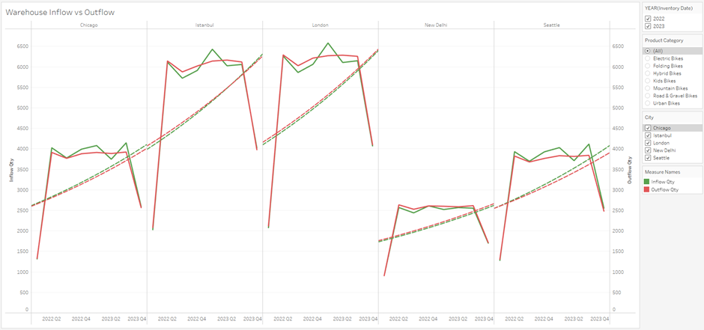

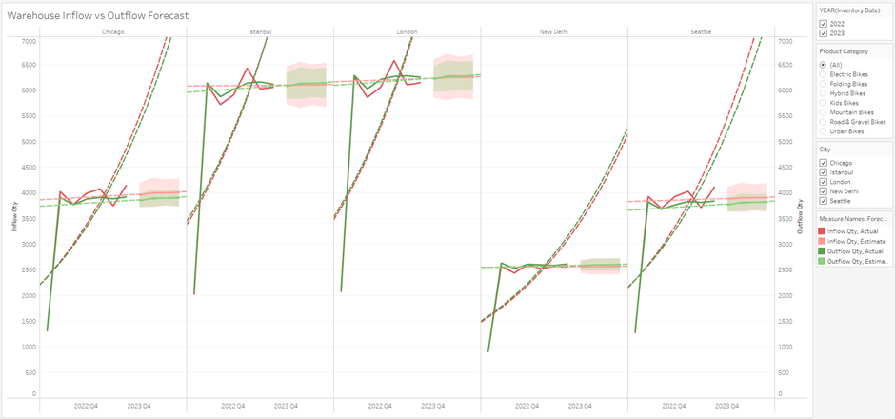

Figure 2. Total Warehouse Inflow vs Outflow for all Product Categories with Forecasts

### Projected Decline of Overall Inventory Turnover Ratio (ITR) of Warehouses

The figure below (figure 3) shows the alarming trends of ITR across ACME warehouses. Currently, the warehouses are doing quite decently but are forecasted to perform worse. Chicago is performing adequately but expected to experience a slight decrease which indicates some minor issues in current management practices. Both warehouses in Istanbul and London are performing in a very efficient manner, but are forecasted to drop to 60% of their initial performance. Although it is still projected to do quite well, this drastic decrease is a sign of potentially major issues regarding the sustainability of current inventory management strategies. Seattle is currently and is expected to still struggle with their low ITR, creating the need for urgent attention.

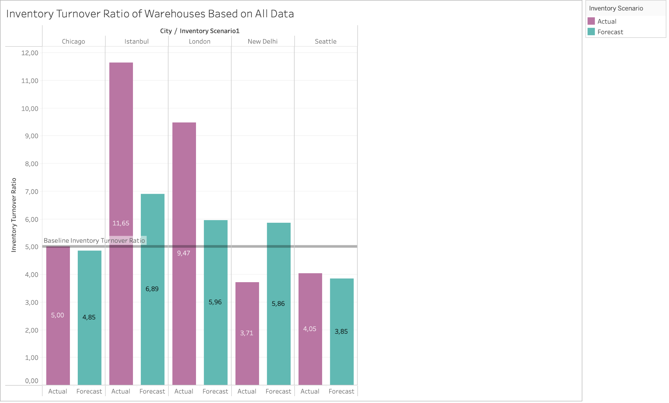

Figure 3. Inventory Turnover Ratio of Warehouses Based on All Data

In short, the visualisation shows an urgent need to re-evaluate current inventory management strategies. Koumanakos (2008) implied that the particular declines of inventory turnover ratios could be derived from poor projections and mismatches with the market demands. These could lead to more frequent overstock / stockout occurrences, negatively affecting the warehouse's performance. Lee at al. (1997) suggested that to increase ITR, a better management of the bullwhip effect could be implemented. By reducing the bullwhip effect, it will lead to a more stable inventory level, improving the warehouse's ITR. This issue can also be addressed by implementing advanced data forecasting techniques and enhancing the warehouse’s supply chain coordination.

### Total Stock Based on Category and Warehouse

The pie charts (figure 4) depicting total stock by category and warehouse during 2023 reveals several key insights. Road and gravel bikes dominate the inventory at 19.95%, reflecting their high demand. Mountain bikes (19.19%) also hold substantial shares, indicating steady demand across versatile market segments. Kids' bikes, comprising 15.92% of the inventory, suggest consistent demand driven by children outgrowing their bikes. Electric bikes, at 8.41%, have the lowest stock levels among major categories, possibly due to their higher unit value and strategic inventory management to avoid overstocking costly items. Folding and hybrid bikes, with 11.61% and 9.32% respectively, cater to niche markets needing compact and versatile solutions. Regarding warehouse distribution, Seattle holds the largest share at 26%, positioning it as a key distribution hub, followed by Chicago at 21%, serving as a central hub for regional distribution. Istanbul (14%) and London (18%) maintain moderate inventory levels, which may indicate higher warehouse performance based on outflow data (figure 1), while New Delhi, with 19%, may have greater carrying costs due to lower outflow values. These insights suggest that aligning inventory with demand, optimising key distribution hubs, and maintaining strategic stock levels, especially for high-value items like electric bikes, are crucial for efficient operations and market responsiveness.

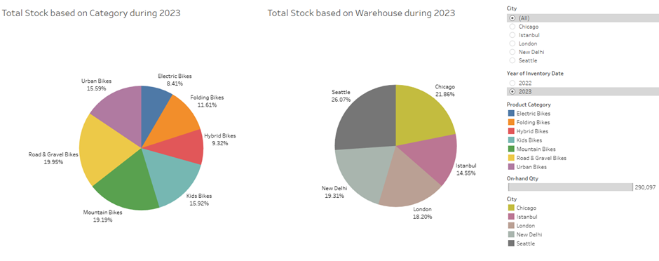

Figure 4. Total Stock by Category and Warehouse During 2023

## Comparative Warehouse Performance

### Potential Overstocking Issue Due to Increase in Days Inventory Ratio (DIR)

Extending from the insights built from the ITR visualisation, it becomes more clear that ACME is currently struggling with their current inventory strategy. Both figures below (figure 5 and figure 6) show the DIR of all ACME warehouses based on actual and forecast data. The lower the number, the better the warehouse’s performance as it indicates a lower number of days held in inventory before being sold.

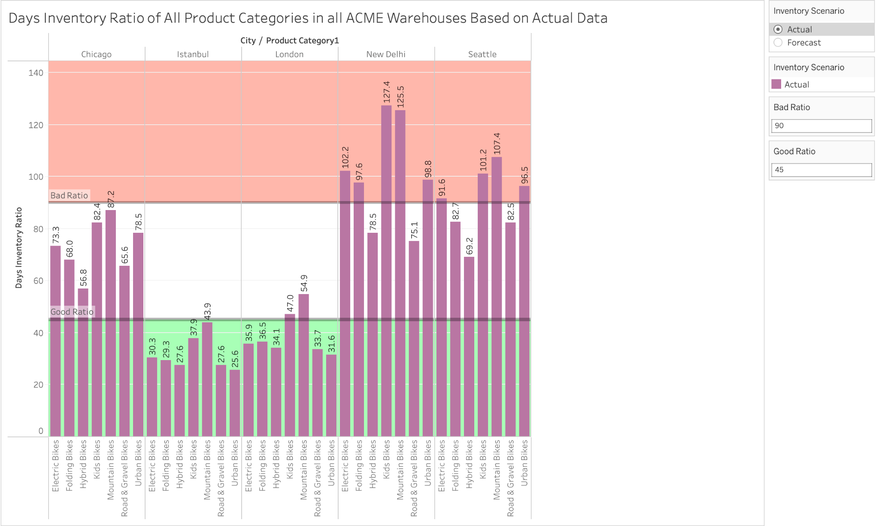

Figure 5. Days Inventory Ratio of Warehouses Based on Actual Data

It can be seen that based on the actual data, most of the warehouses are performing relatively well as there are not many product categories falling into the unsatisfactory rate. Two cities whose warehouses are operating at an outstanding rate are Istanbul and London, with most of their product categories being sold before 45 days. This is not the case for New Delhi and Seattle as most of their product categories fall within the unsatisfactory rate, indicating an average DIR higher than 90. These product categories include electric, folding (only New Delhi), urban, mountain, and kids bikes.

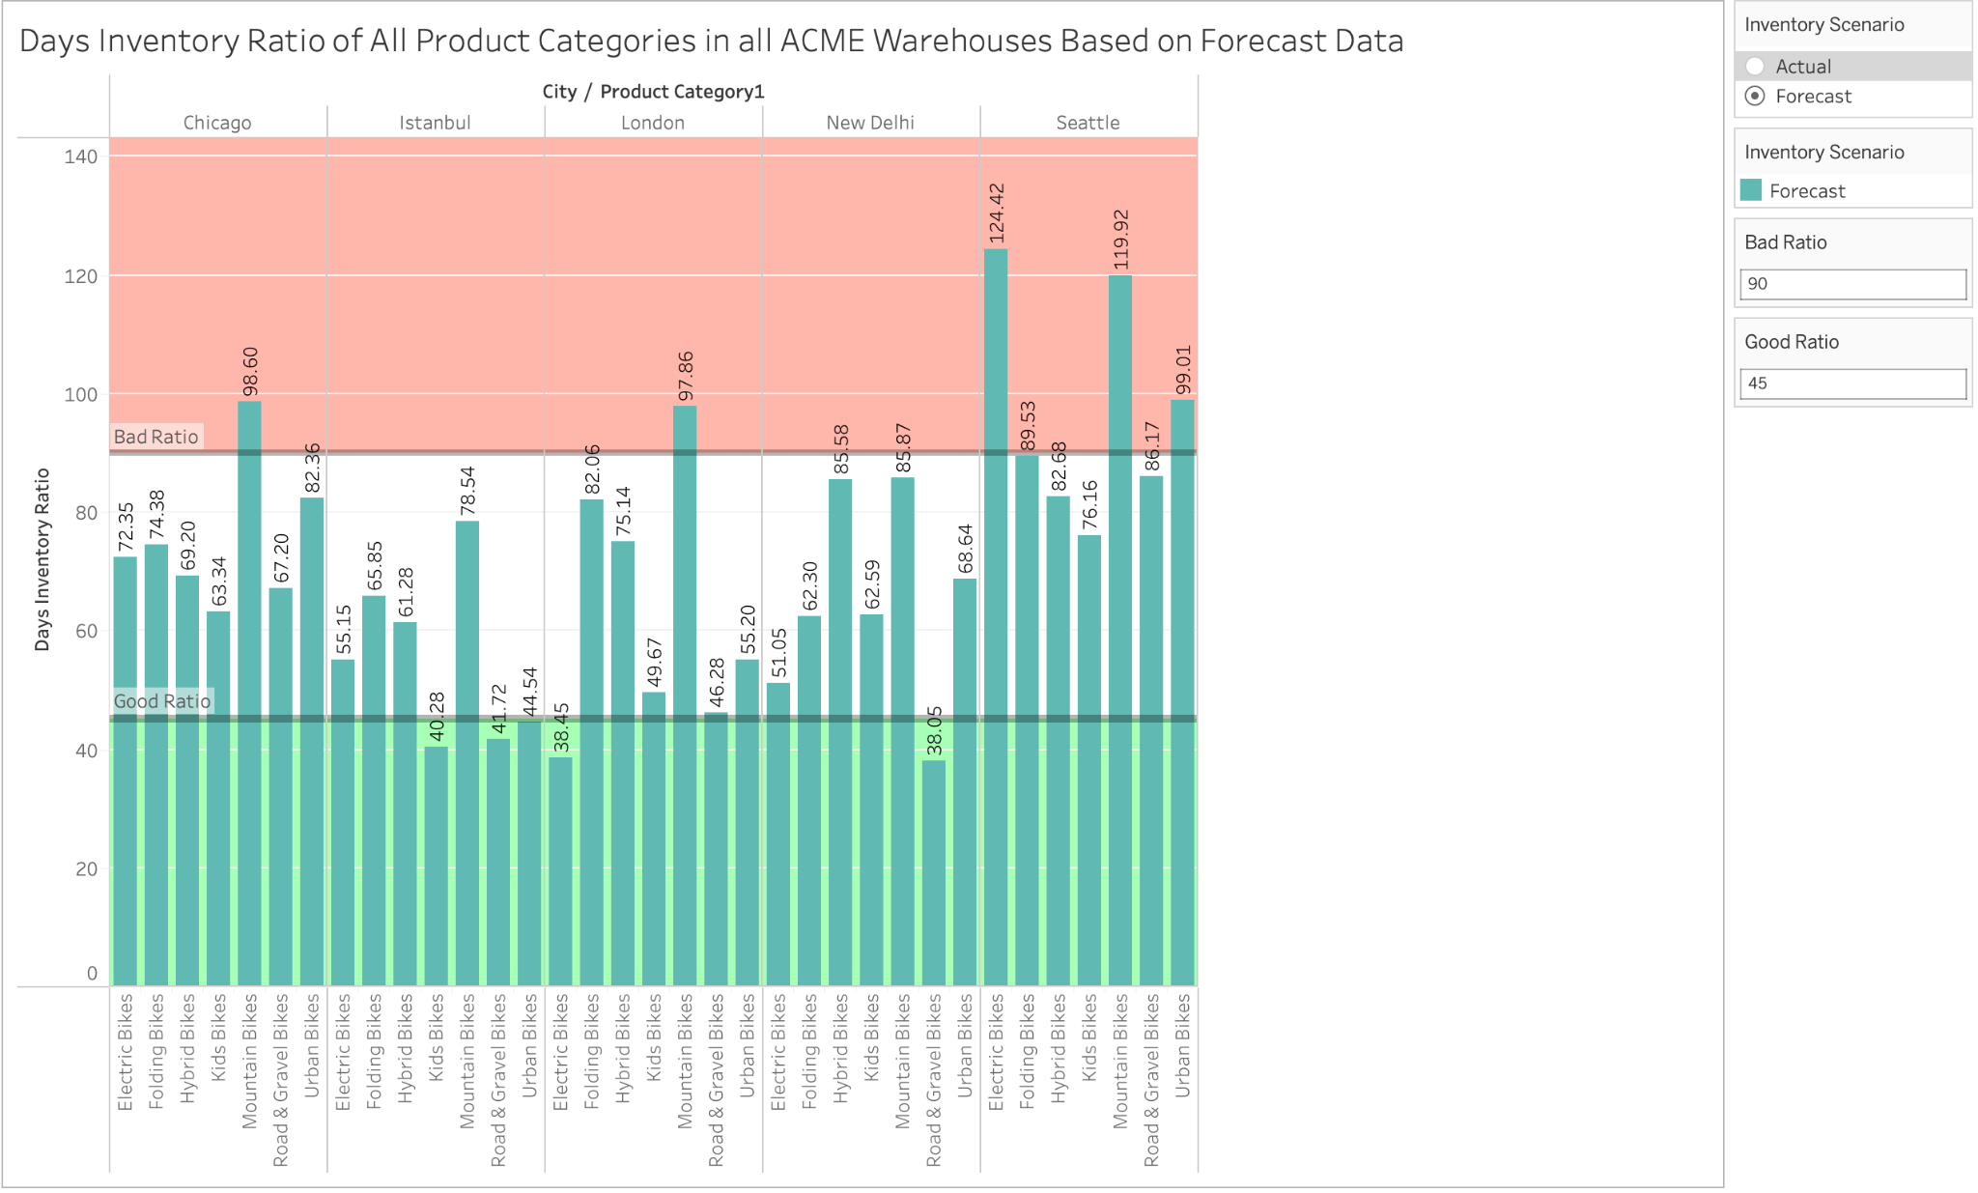

Figure 6. Days Inventory Ratio of Warehouses Based on Forecast Data

As seen in the figure above, almost all warehouses are projected to experience an increase in their DIR, with several product categories of current well performing cities anticipated to be near or exceed the “bad ratio” zone. One of the examples of this is the DIR of electric bikes in Istanbul projected to surpass 98 days, showing signs of inventory inefficiency. However, New Delhi is expected to perform better in the future with current inventory management strategies. Kwak (2019) explains that high DIR results in an increase of holding inventory costs which could negatively affect ACME’s operational efficiency. This creates the urgency for ACME to begin searching for solutions to address the decline in warehouse performances.

### High Value Slow Moving Products

Figure 7 represents the average unit value against the sum of outflow quantities of each product category for a particular year. The total on-hand quantity for each bike category is also displayed for further comparison which matches the same trends as outflows. Based on the visualisation, it can be seen that electric bikes have the highest average unit value however the lowest total outflows for 2022. This trend continues in the following year, however outflow values have slightly improved. As seen in figure 7, electric bikes have the lowest outflow values across all warehouses with New Dehli having the lowest at 713 compared to all other warehouses (1,235 average), which may suggest a number of possible reasons. A high sales price for example can be a key indicator which could be the result of fewer sales. This is validated by the Grand View Research market report (2023) highlighting that electric bikes saw an upsurge in sales during 2022 with e-bikes actually surpassing the sales of electric cars in the U.S. As such, there may be insufficient marketing or customer awareness about electric bikes at ACME, or potential distribution issues preventing electric bikes from being moved efficiently. On the other hand, kid’s bikes have the lowest average unit value with moderate outflows across all warehouses. This trend continues in 2023, however seasonality trends from figure 1 revealed kid’s bikes to have peak outflows during 2023 Q1. Therefore it may be beneficial to consider increasing kid’s bike sales strategies during Q1 as it may be indicative of the holiday season. Conversely, road & gravel bikes saw the highest outflow values across all warehouses which had the second highest average unit value. It can be concluded that road & gravel bikes are ACME’s best performing bike category which has shown an increasing trend from 2022 to 2023. This is favourable for warehouses such as London and Istanbul which have an average of 5,300 outflows in 2023 with steady on-hand quantities, however other warehouses see an average of 3,000 outflows which may indicate greater carrying costs for those warehouses.

Figure 7. Average Unit Value vs Outflows for each Product Category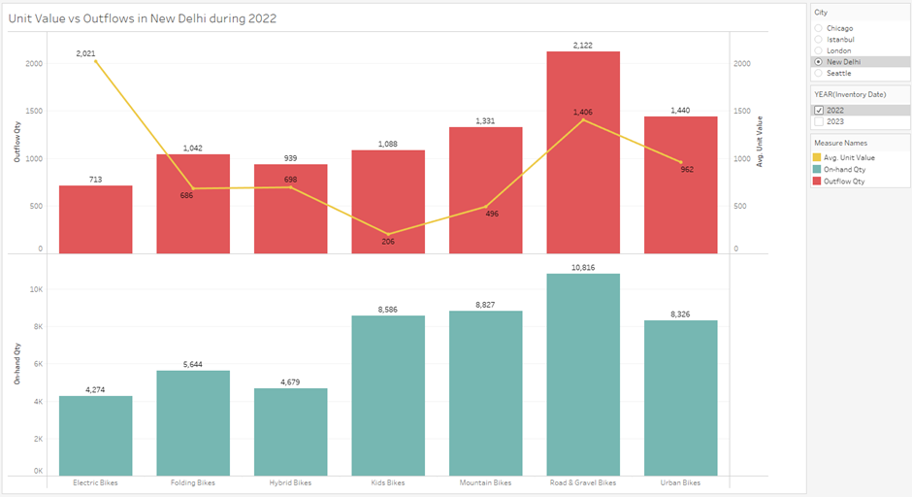

## Item and Product Availability

This section investigates current and forecasted product availability at ACME, focusing on detailed assessments of inventory levels across various product categories. Special emphasis is placed on analysing excess stock, overstock, and levels that fall below safety stock thresholds. To navigate these complex inventory landscapes, we have developed specific criteria based on numerical values extracted from data. This approach enables us to pinpoint discrepancies between actual and predicted inventory outcomes, providing critical insights that guide strategic inventory management and optimization efforts, aiming to synchronise supply with market demand efficiently.

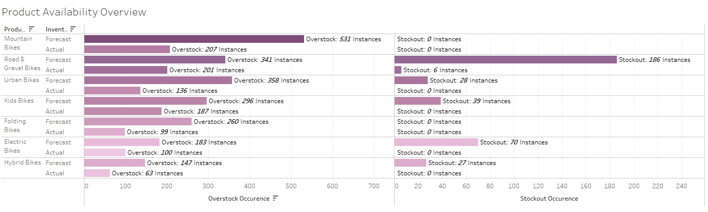

Figure 8. Product Availability Overview

Figure 8 displays the number of stockout and overstock instances in each product category, based on the ACME’s current and forecasted inventory scenarios. Mountain, road and gravel, and urban bikes show a significant overstock in both actual and forecasted scenarios, with road and gravel bikes having the largest forecasted stockout rate. The data indicates a general trend of overstock across all categories, where actual instances are frequently exceeded by forecasted instances, potentially indicating overly cautious inventory management policies and inaccuracies in demand forecasting.

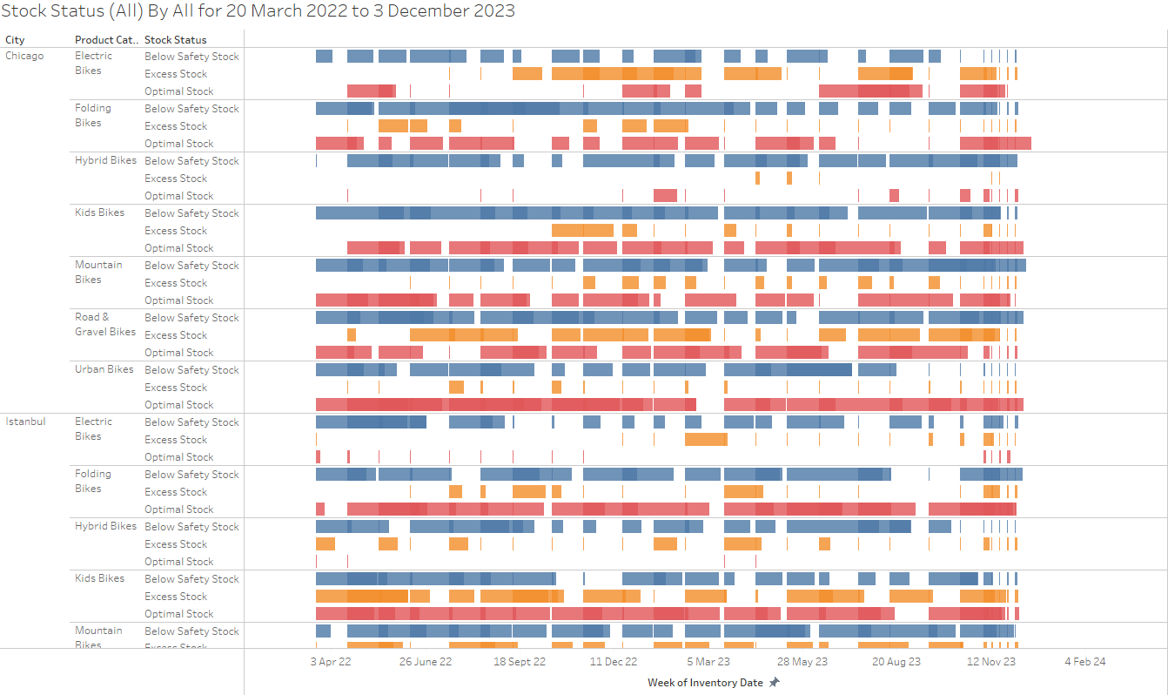

Figure 9. Stock Status Gantt Chart

Figure 9 visualises periods of stock status, assessing if stock on hand is below safety stock quantities, excessive or optimal, across warehouses and product categories. Note, as ACME tracks its inventory with several dimensions across monthly and weekly periods, two or more mutually exclusive stock status can be met at any time. ACME should consider adjusting its inventory recording processes to occur daily to mitigate this factor for future interoperability in analysis.

Fluctuations can be observed across all three stock conditions among different product categories and cities, possibly due to a response in sales trends or customer demands.

Notably, all areas show periods of under stock, while emerging markets such as India in New Dehli display significant demand for Road & Gravel bikes. Conversely, areas where bike infrastructure is limited (Ahsan, 2020), extended periods of over stock are observed in markets such as Turkey.

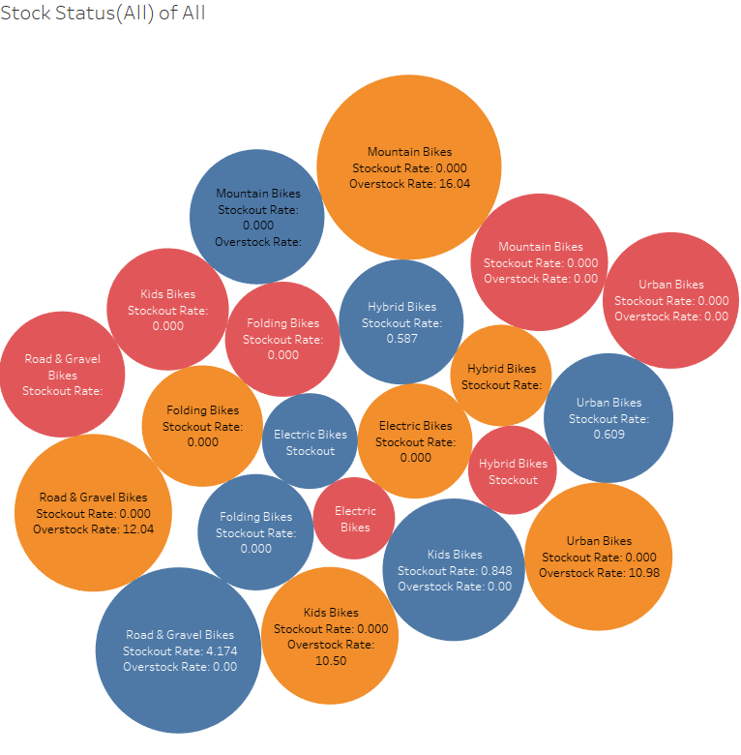

Figure 10. Stock Status By Category

Figure 10 presents an overview of stockout, understock and overstock instances for various categories of bikes. Notably, all categories show high understock instances similar to the figure 9, with Kids Bikes displaying a significant overstock and understock instances, typically occurring during the December holiday period, suggesting seasonal demand during this time.

This presents an opportunity in targeted marketing efforts which may aid in shifting excess stock and reduce storage costs, which will require a comprehensive analysis to be performed on its customer base’s purchasing behaviours, seasonal trends, and regional sales data through the use of advanced analytical techniques and models such as a time series analysis, artificial neural networks and machine learning algorithms.

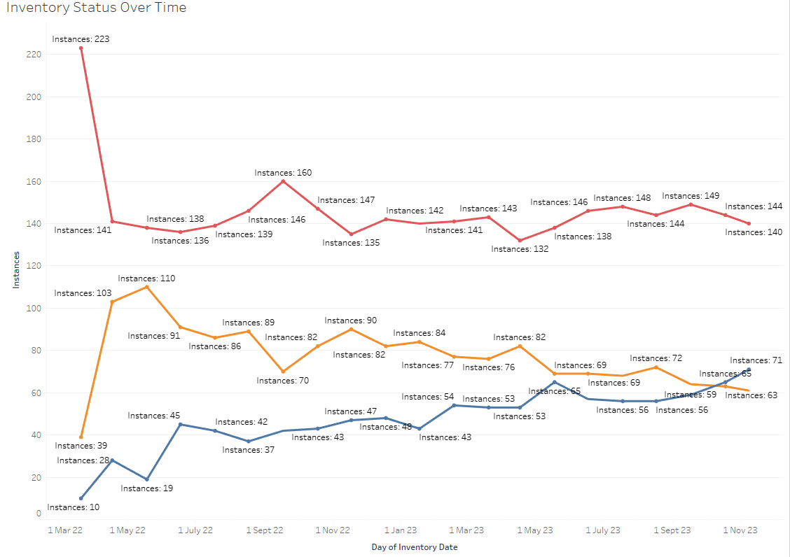

Figure 11. Inventory Status Over Time

Figure 11 provides a representation of stock status over time. Throughout the timeline of dates recorded, below safety stock levels fell from its initial peak and stabilised, potentially indicating robust supply chain operations or minimisation of supply chain disruptions. Optimal stock levels initially showed an increase and was followed by a decline, while excess stock levels display an upwards trend.

### Excess Stock Analysis

This section explores items with excess stock to examine ACME’s overstock management. Clearly shown from the graph, Armanda TTR 900, Van Torino, Hirakl MB100, and Hirakl FR50 consistently appear in the top 5 items with excess stock. This suggests ACME’s inaccurate demand forecasting and product planning, which leads to producing or ordering more stock than necessary. The consistently high overstock rate also indicates ACME’s inefficient inventory management that lacks strategies to reduce the excess stock items. In addition, these 5 items belong to the “Mountain Bikes” & “Road & Gravel Bikes” categories, implying the same issues with managing these two product categories.

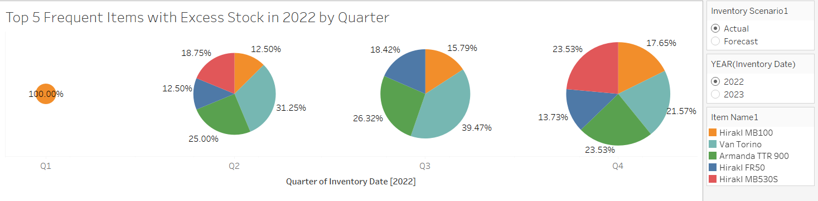

Figure 12. Top 5 Frequent Items with Excess Stock in 2022

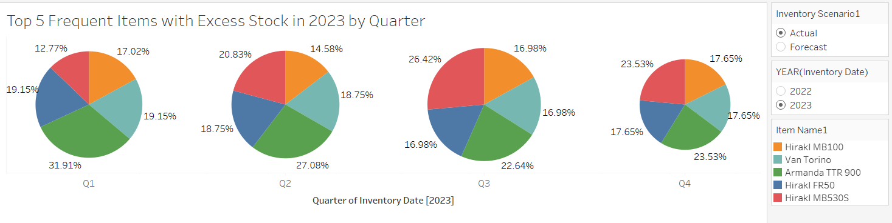

Figure 13. Top 5 Frequent Items with Excess Stock in 2023

Expanding on items with high overstock rates, the line chart below visualises the top 5 overstock items with the highest total sales value. The chart shows fluctuation in the sales values of Armanda TTR 900, Kantouza - CEB100, and Website 560, possibly influenced by seasonal trends. Based on this, ACME can estimate demanded products and develop seasonal promotions for each product to maximise sales value while minimising excess stock. Moreover, TRICA EC200 shows a more consistent and gradual increase in sales value, indicating a steady demand for this product.

On the other hand, Van Torino has a decreasing sales value while being overstocked frequently. Therefore, it is recommended that ACME takes immediate action to reduce the inflow quantity of this product.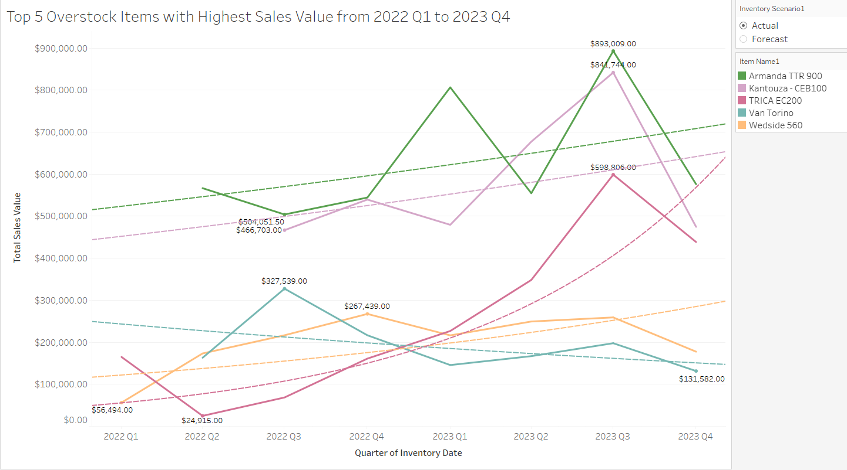

Figure 14. Top 5 Overstock Items with Highest Sales Value from 2022 to 2023

# What-If Analysis

For the What-If analysis, it was decided that the incorporation of both historical and forecast data would be ideal. This is done for the benefit of providing a concrete framework for ACME to navigate current issues within the warehouses and potential uncertainties that may happen in the future. The combination of both types of data will help ACME achieve ideal inventory management as it creates a balance of data weight between historical and expected performance of the warehouse. All three visualisations are embodied with an 11% increase in outflow quantity, aligning with the projected Compound Annual Growth Rate of the bike market.

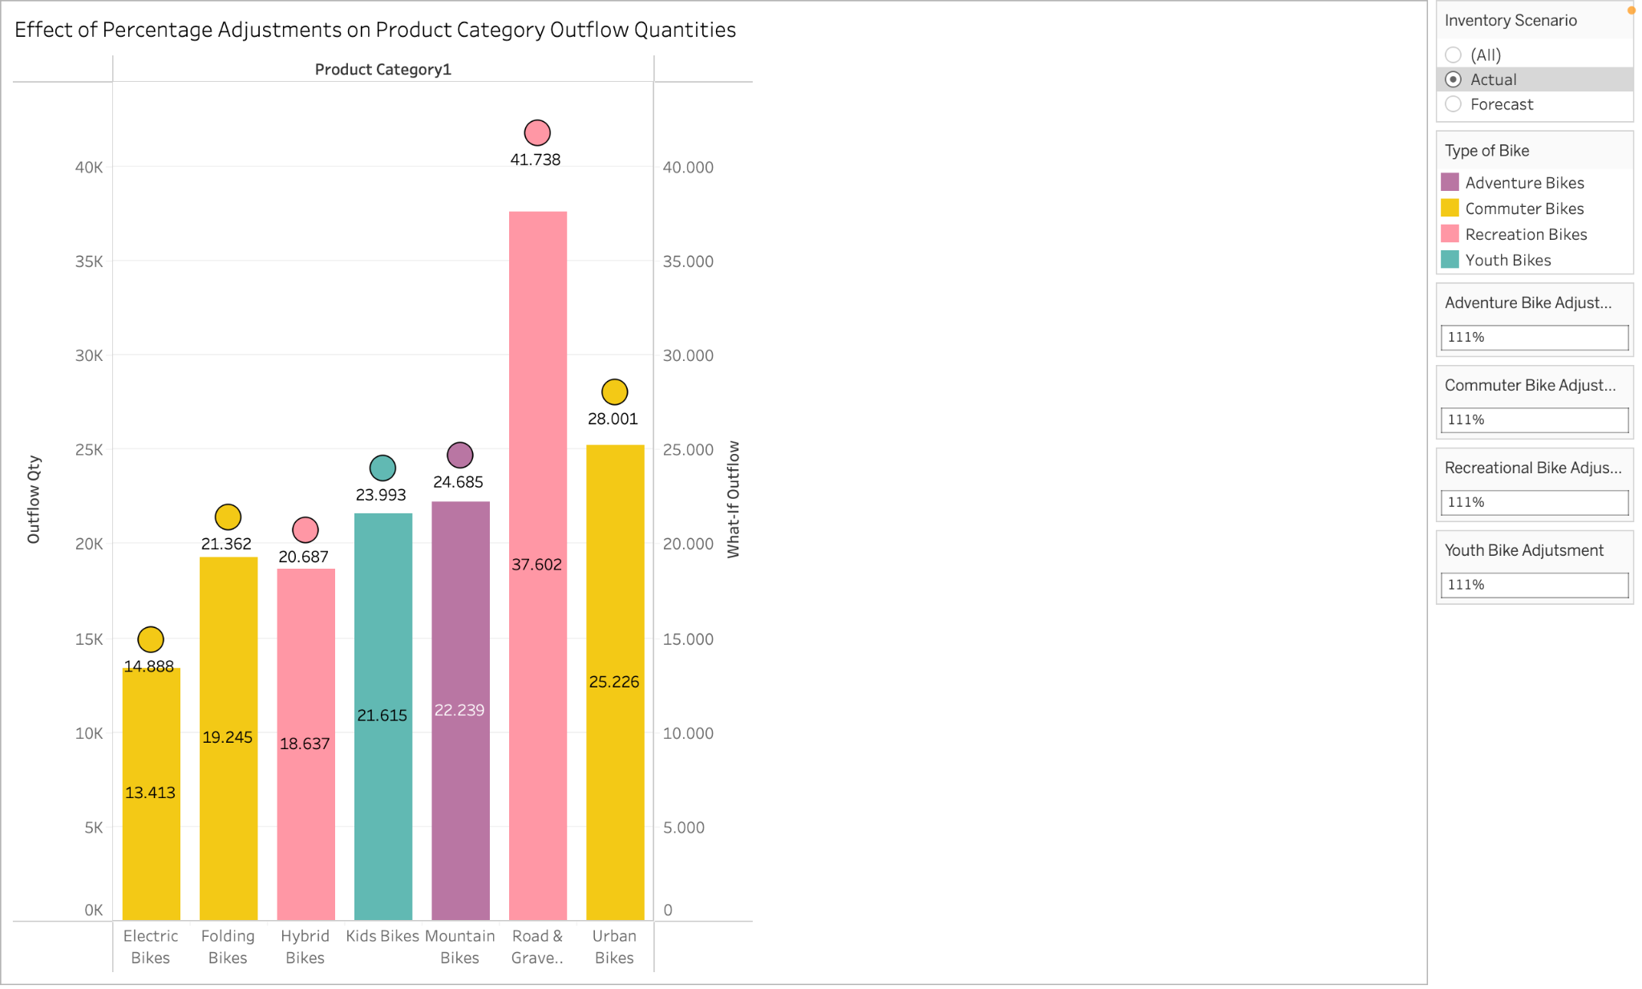

Figure 15. Effect of Percentage Adjustments on Product Category Outflow Quantities

Road & Gravel Bikes are the top performing bike category, having the highest outflow quantity(41,378 units). This is due to the increase of demand for adaptable and adventurous riding options. The increasing popularity of Road & Gravel Bikes also supports this visualisation (Plot Twist: U.S. Performance Bike Sales Rise in June, Reports The NPD Group, 2020). On the contrary, electric bikes show the least increase of outflow quantity (14,888 units). This may be due to the high production costs and varying international policies that are hindering the bike’s market expansion.

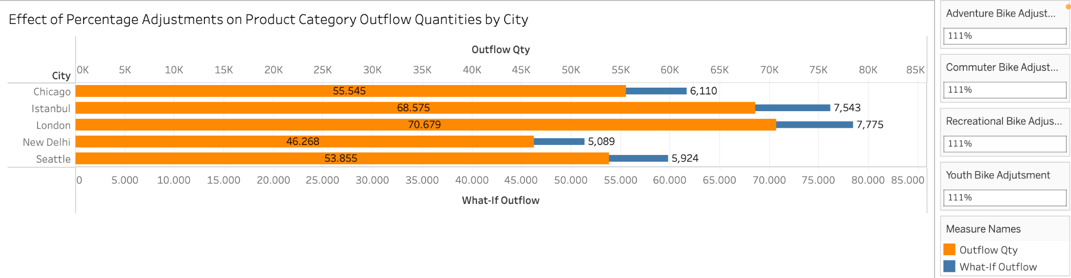

Figure 16. Effect of Percentage Adjustments on Product Category Outflow Quantities by City

The figure above shows the cities and their outflow quantity before and after implementing the 11% increase. London is shown as the most successful city in terms of highest outflow quantity due to its strong cycling trends and supportive cycling infrastructure and policies (Berridge, 2012). It is also followed by Istanbul’s additional 7,543 units. New Delhi has the least projected outflow quantity as issues such as traffic congestion, low quality cycling infrastructure, and safety concerns significantly contribute to this poor performance (Biswas et al., 2019).

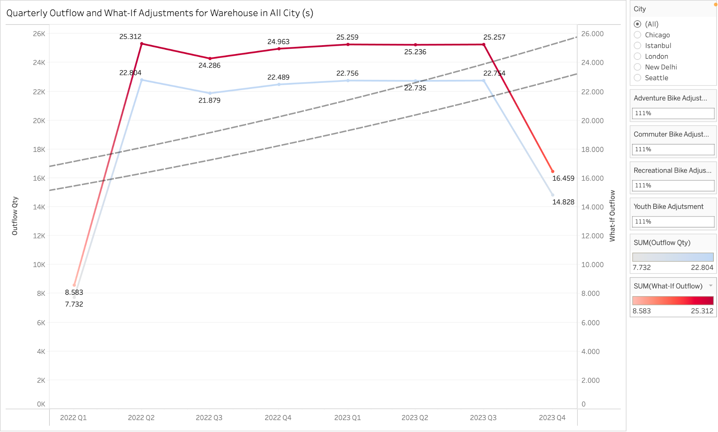

Figure 17. Quarterly Outflow and What-If Adjustments for Warehouse in All City Warehouses

It can be seen that ACME experiences outflow peaks in 2022 Q2, with a projected outflow of 25,312 bike units. Bikes tend to increase in demand during spring and summer as the weather becomes favourable, encouraging people to bike. The lowest projected outflow can be seen as well in 2022 Q1, which is possibly caused by colder weather conditions making it less favourable for biking.

# Conclusion & Recommendations

To conclude, this analysis on ACME’s inventory management has highlighted key critical insights that can drive decision making processes for improved inventory management practices and market alignment. The provided visualisations and data highlight a significant issue in inventory recording practices, overstock and understock issues across all categories, which not only result in increased costs in carrying goods, but also risk customer satisfaction due to potential stockouts. Additional key findings from this analysis indicate that there is an urgent need for improved forecasting techniques and modelling,

Based on this, it is recommended that ACME should implement changes to handle its current overstock and understock discrepancies, improve its current forecasting models by incorporating more granular market data, restructure its current data reporting methodologies, optimising its inventory management and aligning it more closely with regional demand patterns, and incorporating targeted marketing efforts to move excess stock and boost demand where necessary.

# Infographic

# References

1. Ahsan, M.M. (2020). Strategic decisions on urban built environment to pandemics in Turkey: Lessons from COVID-19. Journal of Urban Management. [online] doi:<https://doi.org/10.1016/j.jum.2020.07.001>.
2. Berridge, G. (2012). The promotion of cycling in London: The impact of the 2007 Tour de France Grand Depart on the image and provision of cycling in the capital. *The Journal of Sport Tourism*, *17*(1), 43–61. <https://doi.org/10.1080/14775085.2011.635018>
3. Embarak, O. (2018). The importance of data visualization in business intelligence. Data analysis and visualization using python: analyze data to create visualizations for BI systems, 85-124. <https://doi.org/10.1007/978-1-4842-4109-7_2>
4. Islam, M., & Jin, S. (2019, November). An overview of data visualization. In 2019 International Conference on Information Science and Communications Technologies (ICISCT) (pp. 1-7). IEEE. <https://doi.org/10.1109/ICISCT47635.2019.9012031>.
5. Koumanakos, D. P. (2008). The effect of inventory management on firm performance. *International Journal of Productivity and Performance Management*, *57*(5), 355–369. <https://doi.org/10.1108/17410400810881827>
6. Kwak, J. K. (2019). Analysis of Inventory Turnover as a Performance Measure in Manufacturing Industry. *Processes*, *7*(10), 760-. <https://doi.org/10.3390/pr7100760>
7. Lee, H. L., Padmanabhan, V., & Whang, S. (1997, April 15). *The Bullwhip Effect in Supply Chains*. MIT Sloan Management Review. <https://sloanreview.mit.edu/article/the-bullwhip-effect-in-supply-chains/>
8. *Plot Twist: U.S. Performance Bike Sales Rise in June, Reports The NPD Group*. (2020, August 19). PRWeb. Retrieved May 23, 2024, from <https://www.prweb.com/releases/Plot_Twist_U_S_Performance_Bike_Sales_Rise_in_June_Reports_The_NPD_Group/prweb17337734.htm>
9. *U.S. E-bike Market Size, Share And Trends Report, 2030*. (n.d.). Grand View Research Retrieved May 29, 2024, from <https://www.grandviewresearch.com/industry-analysis/us-e-bike-market-report>